Instruction for https://statmed.kurskmed.com/.
In order to use this resource you need electronic student card number (containing 13 digits) and the student's year of birth for view the grades and achievements of a student.
This information is entered in the appropriate form fields at the bottom of the resource page, then you have to click the "Show achievements" button.
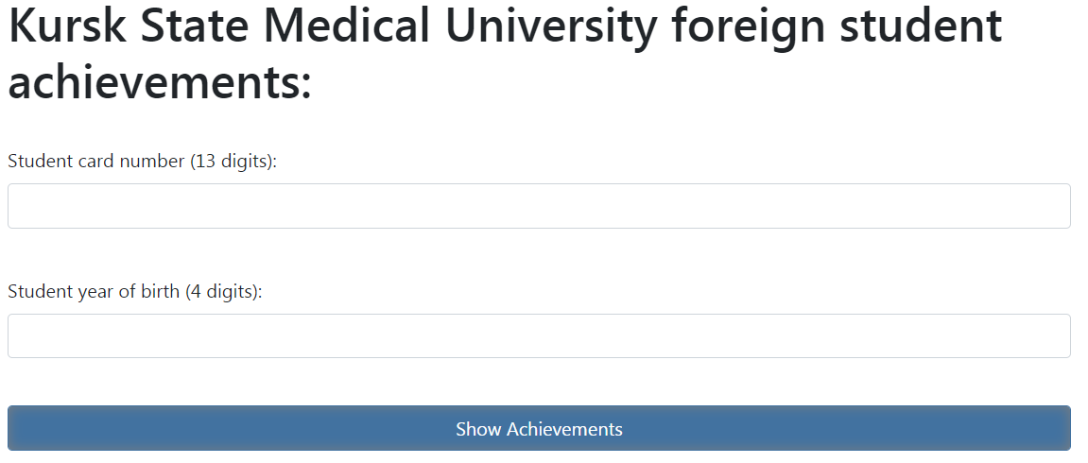
At the next page you’ve got information about previous and current semesters, and the button for viewing student’s opened workingoffs.
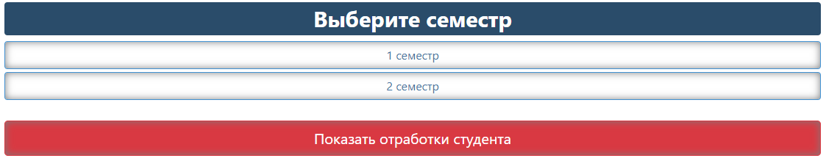
Pressing at the semester you will get information about all subjects at that semester.
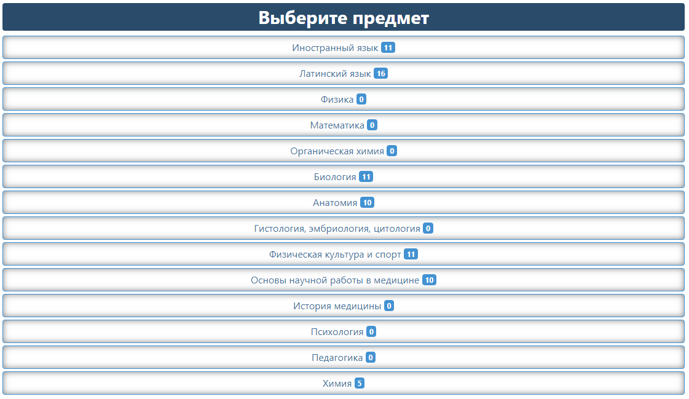
The digit next to the name of the subject shows how many grades the student received in this discipline.
In order to see the scores, you must select a subject. This will allow you to see all the classes, their dates, grades and information about the teacher who conducted the lesson.
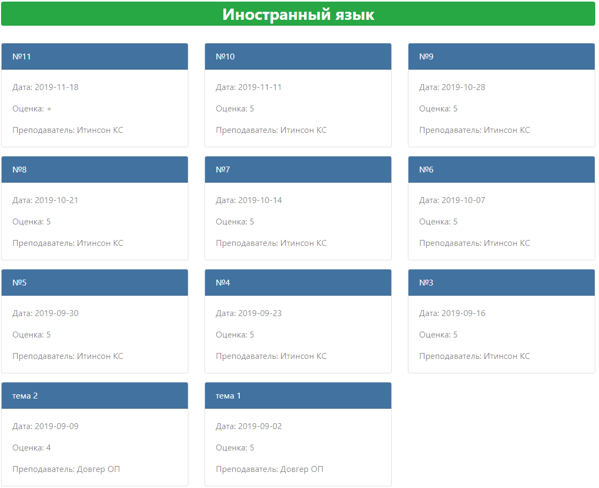
Pressing the button “Show student workingoffs” will allow you to see the workingoffs in all subjects that are currently not closed.
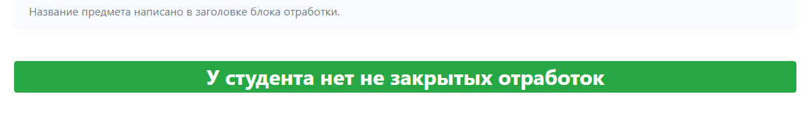
If, when you click on the “Show achievements” button, you see the words “Неверная дата рождения”, “Неправильный номер карты”, check the data and try again. If you see “Заполнять только цифрами”, check if you filled both fields and if there are no unresolved characters in them, then try again.
